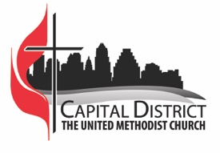
2021 Charge Conference Agenda

Welcome Rev. Laura Merrill
District Superintendent
Opening Prayer

Call to Order

Designation of the Recording Secretary
Normally the Board or Council Secretary, but an alternate may be elected. The secretary’s name should be recorded in the minutes. At group conferences, each church needs its own recording secretary to take minutes.

Charge Conference Business
Reports should be submitted in advance to jill@umcad.org.

- 2022 Church/Pastor Compensation Report

- 2022 Leadership/Nominations Report, including delegates to Annual Conference and Mission Board Lay Representative

- Continuation of Candidates for Ministry, Lay Servant Ministries, and Certified Lay Ministers

- Consent Agenda - the following items are adopted as a group:

- Report of Finance Committee
- Report of Trustees
- Report of Pastor and reports of other clergy affiliated with the charge
- Any other written reports from lay leadership/church ministries

Video Greeting and Message Bishop Robert Schnase

Video on Hybrid Worship (online + in person) – where indicated Rev. Karen Horan

Conversation with the District Superintendent

Adjournment & Sending Forth

Let us hold fast to the confession of our hope without wavering, for he who has promised is faithful. And let us consider how to provoke one another to love and good deeds, not neglecting to meet together, as is the habit of some, but encouraging one another, and all the more as you see the Day approaching.

--Hebrews 10:23-25

