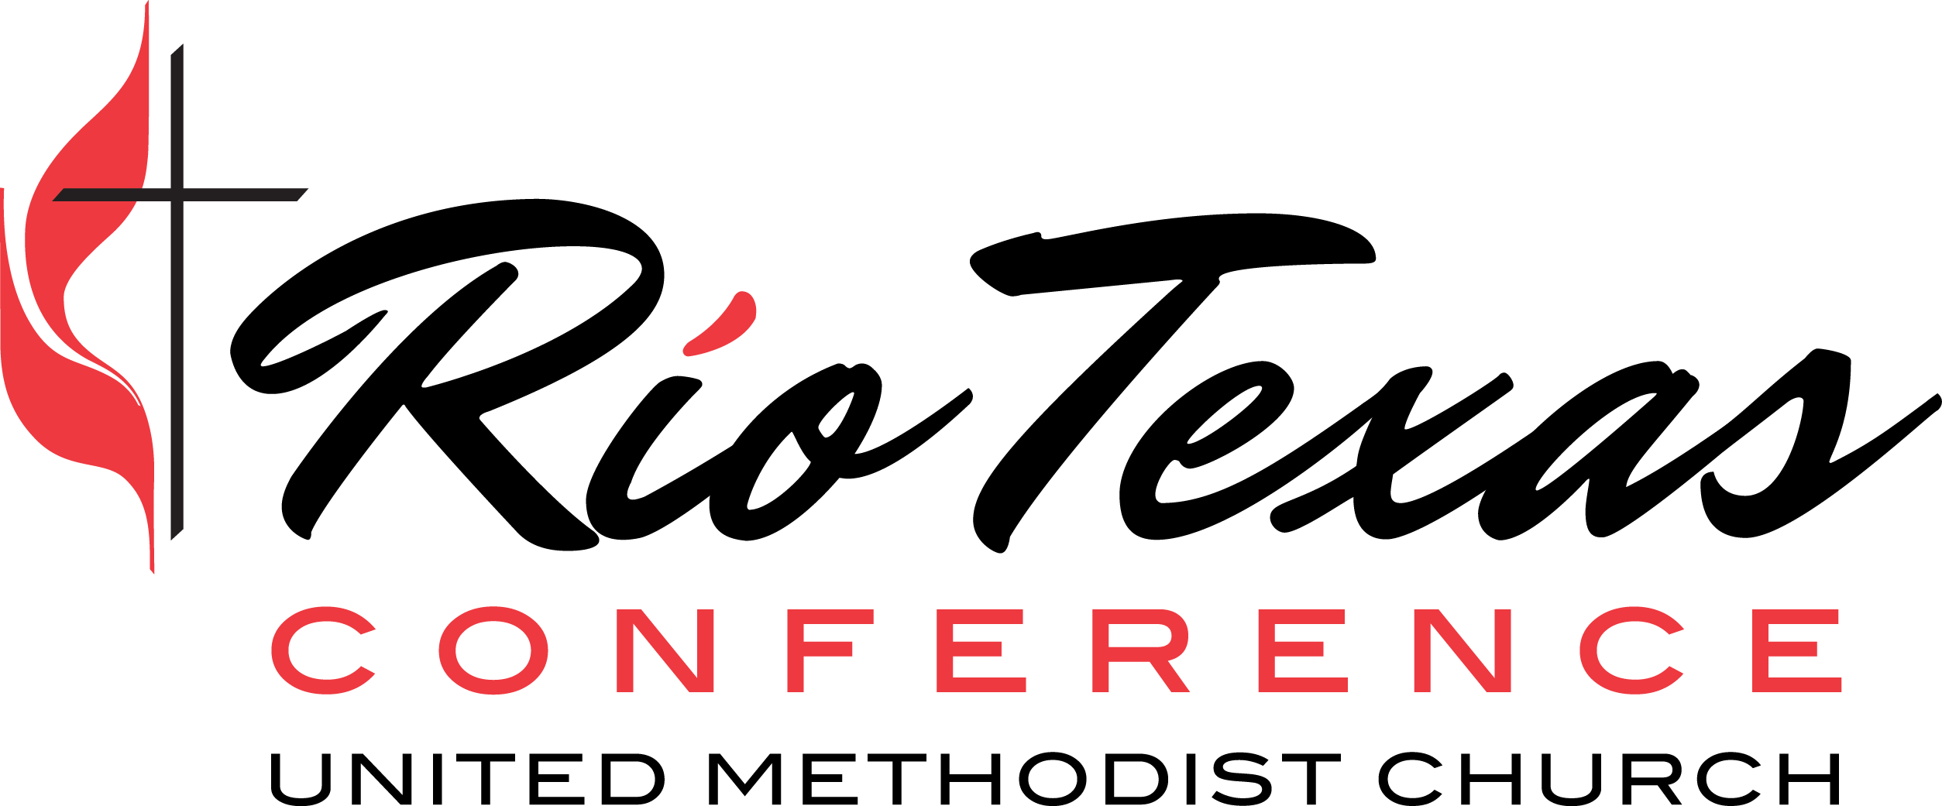

Rio Texas Assessment Questions for Clergy

- What initiative/work currently in progress has the greatest potential to help in fulfilling the mission of your congregation? Why?

- What steps can you take as pastor to improve the initiative/work named above? What steps can the church’s lay leadership take?

- What one or two changes could help your congregation increase its attractional effectiveness? Its missional effectiveness? What steps could you take toward these changes? What steps would be helpful for lay leadership to take?

- What metric-based goal have you set for yourself or your church? How does narrative inform or complement the metric data?

- How are you developing stronger relationships with your leaders and a clearer sense of purpose with them?

- How are you building trust as a leader? What difficult conversations are you convening? What experiments (even small ones) are you undertaking with the relational capital you are developing?

- What do you need to stop doing? Why?

- What training/equipping resources do you need to help maximize your own strengths and respond to areas for growth?

Please be sure to include your name on your responses to these questions and return them to your district superintendent by Thursday, October 17, 2019.

