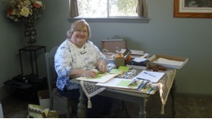

+

+

Helping Hand

Crisis Ministry

Of

Spicewood

A 501 (C) (3) Charity

Who We Are

Welcome neighbor, God loves you!

**Contact Us**

**PO box 142**

**Spicewood, TX 78669**

**(512) 808-6092**

**helpinhandspicewood@gmail.com**

**http://helpinghandspicewood.org**

We are a faith based and all-volunteer organization serving those in need who live in the general area of Spicewood, Texas. We operate out of the Pedernales Property Owners Association building located at 512 Pace Bend Road North near the Briarcliff community. We are open on Tuesdays from 4:00 to 6:00 PM. Financial support comes from 10 church organizations, several corporate grants, over 150 individual donors, and several fund raising events. Our annual budget is over $140,000 with 89% being used for direct client assistance.

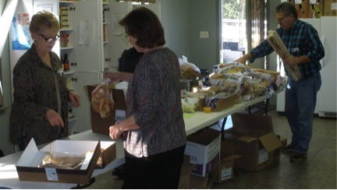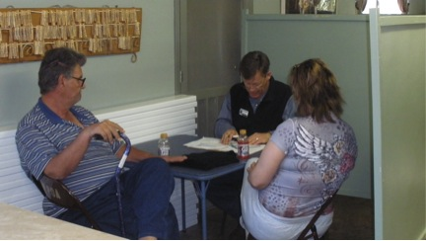

**Compassionate Listening:** One of the most important things that we do is to listen. We are not professional counselors, but we have a group of volunteers with very large hearts who have developed a real talent in listening and talking with clients about their problems. Of course, we offer prayer as a source of renewed hope that God is still there for them through their crisis.

+

**Food Pantry:** Last year, we provided food and personal hygiene products to 305 different families of which 104 were first-time clients. We are blessed to have the support of the Capital Area Food Bank of Texas.

**Financial Assistance:** Due to unfortunate circumstances such as loss of employment, serious illness, or family trauma, 271 client families received financial help last year. Clients requesting financial help are interviewed to get a better understanding of their situation. If appropriate, we provide help that is generally focused on housing, transportation or medical & dental expenses.

**Emergency Housing:** We provide emergency housing for clients and their families who would otherwise be homeless by paying for their stay in budget motels. Typically, their stay is only for a few days but in some cases, we have provided extended stays up to several weeks. Last year we provided emergency housing for 15 client families.

What we do

The purpose of what we do is to love and care for our neighbors with tangible help and spiritual encouragement consistent with the Great Commandment, “Love your God with all your heart, soul, mind, and strength. Also, love others as yourself.”