**Covenant Care Ministries**

Covenant United Methodist Church

4410 Duval Rd

Austin, TX 78727

April 2021

**2021 Growth Projections**

As everyone is aware 2020 was a very difficult year for many people and organizations. The Covenant Care ministries was positioned to see first hand the issues with making sure the greater community of Austin was kept fed. The food pantry that is operated at Covenant UMC has seen a tremendous growth during 2020 beginning in the March time frame thru to today.

In previous years the food pantry has seen an increase in clients of approximately 5-10% per year. During the year 2020, the pantry saw increases of 18.8% and 31.5% in households and individuals served, respectively.

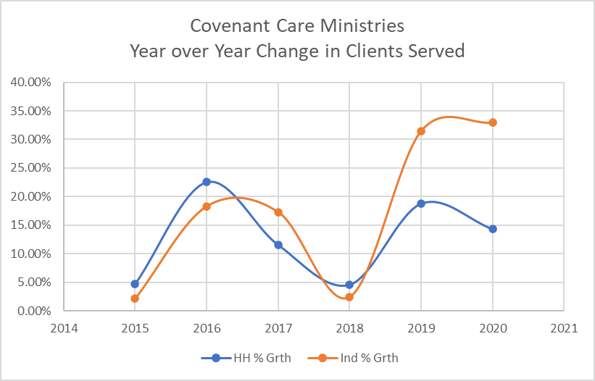

The number of households and individual family members served surged in absolute values tremendously during the same period.

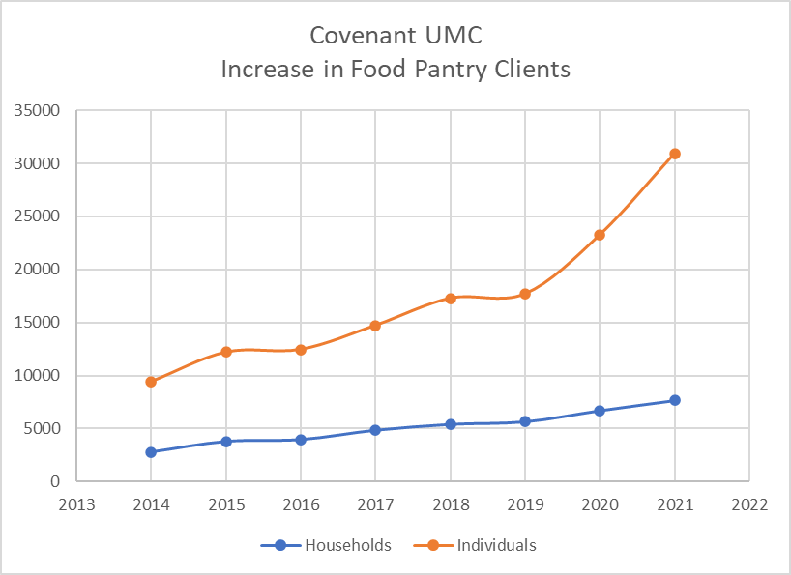

Plans were put in place for 2020 to expand the flow of clients through our indoor pantry by approximately 10% from 2019 values. This was an ambitious project that would have seen the opening of a wall in the current layout of our indoor facility to allow a smoother flow through the pantry. This would have minimized the cross traffic of clients entering and exiting as well as the staff moving from space to space to refill the shopping tables. This plan was put on hold during the early part of 2020 but as the year wore on it became obvious that time was on our side to accomplish this expansion goal.

Funds were made available through our own budget. In 2021 construction was begun. The project was broken in to two phases. As of this writing Phase 1 of the project is about a third to one-half complete. The remaining portion of Phase 1 should be completed soon. We will be within the initial budget of $5,100 to complete this portion.

Phase 2 will see a need to an additional $5,000 to complete. This will involve adding an extra exterior entrance with concrete walk way. This will require a builder that is familiar with the permitting of such a project. The requested grant would help with the completion of this phase of our expansion.

**New Equipment**

Currently the food pantry has two commercial refrigerators and one commercial freezer. Once phase 1 of the expansion of the indoor pantry is complete, we will need additional refrigeration and freezer capacity. Each week we receive deliveries of fresh, refrigerated and frozen food from the Central Tx Food Bank. To store the food prior to delivery to the clients we are now using all of the pantry’s refrigerators and freezer combination as well as an additional freezer in the church’s kitchen.

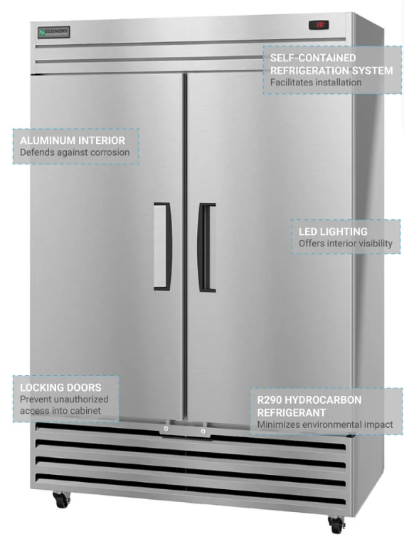 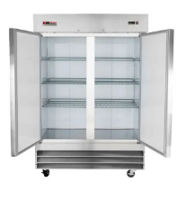

Commercial Refrigerator (38.6 cu ft) Commercial Freezer (46 cu ft)

These two units will cost approximately $2,323 and $2,400 each, respectively.

The cooler boxes that are in use for the point of delivery of the cool and frozen foods are deteriorating. The damage to these Styrofoam coolers is becoming more and more evident as they become stained and physically damaged from normal wear and tear. Currently we have 50 of these units that need to be replaced. The average cost at a discounted price is $10.70 each, for a total of $535.00.

**Budget**

The grant we are requesting will enhance our delivery of food to our clients, who come from all locations with in the Austin Metro area. Currently, we are in a reasonably good position to purchase groceries/food due to the steep discounts offered by the Central Texas Food bank. Our total grant request for 2021 is $10,278.



We have appreciated the assistance the Capital District has provided in the past years. We look forward to continue serving the people of God in the coming years.